|  |  |  |
| --- | --- | --- |
| October 2– 3, 2018  First Annual MSLBMDA  Women In Industry Leadership Conference  **Denver, Colorado** At this conference we will:  * **Define the Leadership Challenges of Today** * **Learn Keys to Professional Growth and Development** * **Study the Relationship Between Management, Leadership and Power** * **Construct a Community of Women to Support Conference Participants as They Move Forward in Their Careers** | ***Conference Schedule-at-a-Glance***   * **Tuesday, October 2** * **Opening Session 2-5 PM** * **Networking Reception – 6:00 PM** * **Dinner – 7:00 PM** * **Wednesday, October 3rd** * **Morning Session – 8AM – 11:30 AM** * **11:30 – 1:00 Networking Lunch** * **1:00 – 4:00 – Afternoon Session**   **The Omni Interlocken Hotel – West of Denver, Colorado**  See the source image  **Who Should Attend?**  **Women in all stages of their careers who are either in leadership positions or aspire to move into leadership positions. You will have an opportunity leverage educational opportunities to advance your career, as well as meet professional women from all facets of the LBM industry. Come join us – we are committed to making a difference in the LBM Industry!**  **Facilitator: Jan Flynn, Ph.D., Purdue University, Associate Professor Georgia College and State University, Organizational Development/Communications** | Conference Schedule  October 2nd Opening Session – 2-5 p.m.  Networking Reception - 6:00 P.M.  Dinner - 7:00 p.m.  October 3rd Session – 8 a.m. – 4 p.m.  The MSLBMDA Women in Industry Conference provides an environment for female professionals within the LBM Industry to experience professional growth and development. Attendees will have the opportunity to form mentorships, share career challenges and best practices, and leverage educational opportunities.  _________________________   Who Should attend?  This Confererence is ideal for women in the LBM industry who are in pursuit of leadership positions in their career. Whether C-level or aspirational in leadership and management roles, this conference will provide opportunities to connect with women from all areas of the LBM industry.  ────  Add More Great Info Here!  ────  FOr more information contact us at:  Mountain States Lumber and Building Materials Association - MSLBMDA  8480 E. Orchard Road Suite 3000 Greenwood Village, Colorado  80111  **303.793.0859**  [**info@mountainstateslumber.com**](mailto:info@mountainstateslumber.com)  **www.mslbmda.org** |

Mountain States Lumber and Building Material Dealers Association 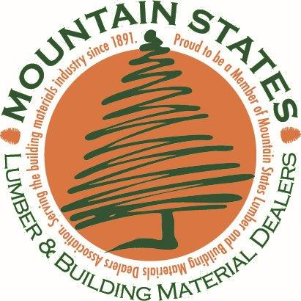

**8480 E. Orchard Road, Suite 3000**

**Greenwood Village, Colorado 80111**

**303.793.0859**

[**info@mountainstateslumber.com**](mailto:info@mountainstateslumber.com)

**www.mslbmda.org**

Attendee Name:_________________________________________________________

Company:_____________________________________________________________

Position:______________________________________________________________

Company Address:_______________________________________________________

Contact Info: E-mail__________________________________Phone:_______________

***Cost: Fees Cover All Session Fees, Materials, Hotel and Meals***

**Member rate: 1295.00 Non-Member rate: 1895.00**

Credit Card: (number)_____________________________________________________

CCV:__________________Expiry Date:_______________Billing Address Zip:__________

Please Invoice Me:_______Mail to Attention of:___________________________________

*Payment in full is due no later than September 15th. Cancellations due by September 15th for full refund.*

*E-mail confirmation with reservation details will be mailed to attendee upon payment for conference. We look forward to welcoming you to Denver and Mountain States Lumber!*

